**Figure B**. The HPV vaccine initialized rate on the Long Island among 9- to 13-year-old kids. The rate here was calculated by the number of kids who already initialized the HPV vaccination divided by the number of kids either receive the HPV vaccination or Tdap vaccination.

1. Gender Disparities of the Rate in Kids (9-13).
2. Rate among Nassau Kids Gender Disparities (9-13).
3. Rate among Suffolk Residents Gender Disparities (9-13).
4. Rate among Kids in Different Races Group (9-13).

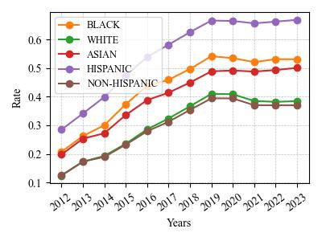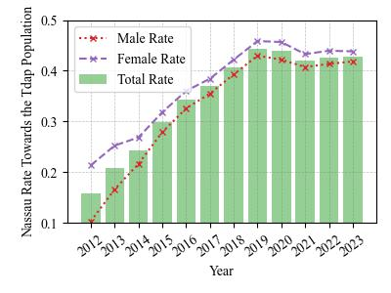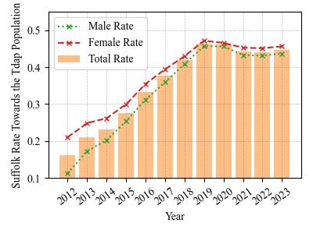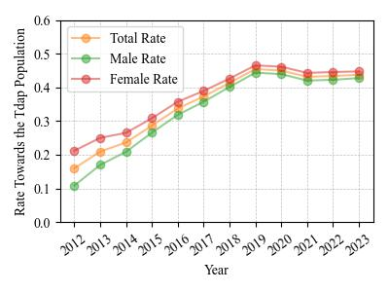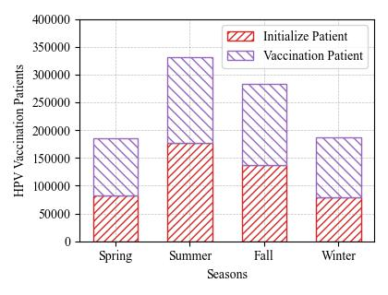

1. HPV Vaccinated Patients Seasonal Preference.

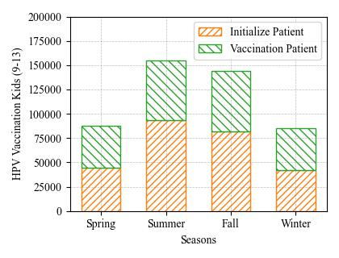

1. HPV Vaccinated Kids (9-13) Seasonal Preference